CHAPTER 1
INTRODUCTION
1.1 OVERVIEW OF THE PROJECT
In the modern digital era, campus recruitment has become an important part of a student’s academic and professional journey. However, many students face difficulties in understanding their placement readiness, identifying skill gaps, preparing for technical and HR interviews, improving their resumes, and finding suitable placement opportunities. Traditional placement processes often depend on manual verification of student profiles, resume screening, eligibility checking, and interview preparation, which can be time-consuming and may not provide personalized guidance to every student.
To address these challenges, the proposed project, CareerReady AI – Campus Placement and Candidate Readiness Platform, provides an integrated web-based solution that helps students assess and improve their overall placement readiness. The system brings together student profile management, skill tracking, ATS-based resume analysis, company eligibility matching, mock interview preparation, personalized recommendations, and placement analytics within a single platform.
The system uses Artificial Intelligence (AI) to provide personalized assistance in important placement-related activities. The AI-based resume analysis module evaluates uploaded resumes and provides an ATS-oriented assessment, helping students identify missing skills, improve resume content, and understand their suitability for specific job requirements. The AI interview module generates technical, HR, behavioral, coding, and company-oriented questions and evaluates student responses to provide feedback and performance insights.
The platform also incorporates a Retrieval-Augmented Generation (RAG) approach using a structured knowledge base to support interview question generation and evaluation. Company-specific interview information and technical question banks are used along with AI services to generate more relevant practice sessions. The system can also evaluate coding submissions and provide feedback on areas such as solution quality and time and space complexity.
The application is developed using SvelteKit and Svelte for the frontend and application interface, with Tailwind CSS used for responsive and modern styling. Firebase Authentication is used for user authentication, while Cloud Firestore is used for storing student profiles, skills, applications, interview records, notifications, company information, and other application data. Chart.js is used to present placement and performance analytics in graphical form. The system also provides separate functionalities for students and placement administrators.
The major modules of the proposed system include User Authentication, Student Profile Management, Skill Management, ATS Resume Audit, AI-Powered Interview Preparation, Company and Placement Drive Management, Eligibility and Application Management, Personalized Recommendations, Reports, Notifications, and Administrative Analytics. These modules work together to provide students with a centralized environment for continuously monitoring and improving their placement preparation.
Overall, the CareerReady AI platform aims to reduce the limitations of conventional placement preparation by combining web technologies, cloud-based data management, artificial intelligence, and personalized assessment. The system helps students understand their current readiness, identify areas for improvement, practice relevant interview skills, and access suitable placement opportunities through a centralized and intelligent platform.
  - OBJECTIVE OF THE PROJECT
The primary objective of this project is to develop an intelligent Campus Placement and Candidate Readiness Platform that helps students assess, improve, and monitor their placement preparation through artificial intelligence, personalized recommendations, resume analysis, interview preparation, and placement management features. The system aims to provide a centralized platform that connects students and placement administrators while reducing the limitations of traditional placement preparation methods.
- Student Profile and Skill Management: Provide students with a centralized profile to maintain their academic details, skills, projects, certifications, achievements, and other career-related information required for placement preparation.
- ATS-Based Resume Analysis: Analyze uploaded resumes using AI-based techniques to evaluate resume quality, identify missing skills and important information, and provide suggestions for improving the resume according to placement and job requirements.
- AI-Powered Interview Preparation: Provide personalized interview preparation by generating technical, HR, behavioral, coding, and company-oriented questions based on the student's skills, profile, and selected placement requirements.
- Skill Gap Identification and Recommendations: Identify gaps between the student's existing skills and the skills required for targeted job opportunities and provide personalized recommendations for improving the required skills.
- Company and Placement Drive Management: Allow placement administrators to create and manage company profiles, placement drives, job requirements, eligibility criteria, and application details while enabling students to view and apply for suitable opportunities.
- Eligibility and Application Management: Automatically compare student information with company eligibility requirements and help students identify suitable placement opportunities while maintaining application records.
- Performance Tracking and Analytics: Track student interview performance, skill development, application progress, and placement-related activities through reports and graphical analytics to help students understand their preparation progress.
- AI-Based Personalized Assistance: Integrate Artificial Intelligence to provide personalized feedback, resume improvement suggestions, interview questions, skill recommendations, and career preparation guidance based on individual student requirements.
- Secure Cloud-Based Data Management: Use Firebase Authentication and Cloud Firestore to provide secure user authentication and centralized storage of student profiles, skills, resumes, applications, interview records, company information, and other placement-related data.
- User-Friendly Placement Platform: Develop an easy-to-use and responsive web application that provides separate functionalities for students and placement administrators, enabling efficient management of placement preparation and recruitment activities.

1.3 LITERATURE REVIEW
The literature review for this project focuses on recent research from 2023 to 2025 in the areas of Artificial Intelligence, resume analysis, job recommendation, skill matching, and interview preparation. These studies provide useful ideas for developing the proposed CareerReady AI – Campus Placement and Candidate Readiness Platform.
In this section, Panchasara, Gupta, and Sharma (2023) proposed an AI-based job recommendation system using BERT. The system used NLP and BERT to understand user profiles and job descriptions. It mainly focused on recommending suitable jobs to users. This study provides a basic idea for the job recommendation feature of CareerReady AI.
In this section, a 2023 study titled An Advanced Real-Time Job Recommendation System and Resume Analyser focused on analyzing resumes and recommending suitable jobs. The system used NLP techniques to compare resume information with job requirements. The study mainly focused on resume analysis and job matching. This provides a basic foundation for the resume analysis feature of CareerReady AI.
In this section, ResumAI: Revolutionizing Automated Resume Analysis and Recommendation with Multi-Model Intelligence (2023) proposed an automated system for analyzing resumes. The system used NLP and AI techniques to extract information from resumes and compare it with job requirements. The study mainly focused on improving resume analysis and recommendation. This idea is useful for the ATS resume analysis module of CareerReady AI.
In this section, AI-Powered Model for Intelligent Resume Recommendation and Feedback (2024) focused on comparing resumes with job requirements and providing feedback. The system helped users understand how well their resumes matched specific job requirements. This study provides a basic idea for the resume improvement and skill-gap features of CareerReady AI.
In this section, Development of a Recommendation System for Resume Tracking and Job Suggestions (2024) used Generative AI and NLP to analyze resumes and suggest suitable job opportunities. The study mainly focused on job suggestions based on resume information. This research provides a foundation for the personalized recommendation feature of CareerReady AI.
In this section, Almalki, Al-Alsheikh, Bahareth, Abdullah, and Alsahafi (2025) proposed a BERT-based job recommendation system using a LinkedIn dataset. The system used BERT to match user profiles with job descriptions. The main focus was job recommendation based on skills and preferences. This study provides a basic reference for the job matching feature of CareerReady AI.
In this section, Deshmukh and Raut (2025) studied BERT-based NLP for automated resume screening and candidate ranking. The system extracted skills from resumes and compared them with job descriptions. The research mainly focused on automated resume screening. This study provides a foundation for the ATS-based resume analysis and skill matching features of CareerReady AI.
In this section, Koshti, Gosavi, Pagar, Khairnar, and Talekar (2025) proposed an AI-powered interview preparation system. The system focused on resume analysis, HR interview practice, and technical skill assessment. The study showed that AI can help candidates prepare for interviews. This idea is used in the AI interview preparation module of CareerReady AI.
In addition to these studies, the existing research shows that AI and NLP can be used for resume analysis, job recommendation, skill matching, and interview preparation. These studies mainly focus on one or two functions of the recruitment process.
However, existing systems do not provide all these features together in a single student-oriented platform. There is a need for a system that combines resume analysis, skill management, skill-gap identification, interview preparation, recommendations, placement drives, eligibility checking, applications, and performance tracking.
Drawing from these studies, this project proposes CareerReady AI – Campus Placement and Candidate Readiness Platform. The system combines these features into one platform using Artificial Intelligence, NLP, SvelteKit, Firebase, and Generative.
Thus, the proposed CareerReady AI platform extends the basic ideas found in previous research by combining multiple placement-related features into a single system. It provides students with a simple and centralized platform for placement preparation and also helps placement administrators manage companies, placement drives, eligibility, and applications.
CHAPTER 2
SYSTEM ANALYSIS
2.1 PROBLEM DEFINITION
Students face many difficulties during campus placements. They may not know whether they are ready for a job, which skills they need to improve, how to prepare their resume, or how to perform well in interviews. Traditional placement systems mainly provide job information and application facilities but do not provide enough personalized guidance to students.
Resume checking and candidate screening are also often done manually. Students may find it difficult to understand whether their resume matches a company's requirements. Placement administrators also need to manage student details, company information, placement drives, eligibility criteria, and applications, which can take more time and effort.
To solve these problems, there is a need for a simple and centralized platform that helps students prepare for placements. The proposed CareerReady AI platform provides features such as student profile management, skill management, resume analysis, skill-gap identification, AI interview preparation, job recommendations, company and placement-drive management, eligibility checking, and application management.
The system uses Artificial Intelligence and Natural Language Processing to provide personalized guidance based on the student's profile, skills, resume, and placement requirements. It helps students improve their resumes, identify missing skills, practice interviews, and find suitable placement opportunities.
Thus, the proposed system provides a single platform for students to improve their placement preparation and helps placement administrators manage campus recruitment activities more efficiently.

2.2 EXISTING METHOD
Existing campus placement systems mainly provide basic services such as student registration, company information, job details, and application management. Students can view available placement opportunities and apply for companies based on the given eligibility criteria.
Most existing systems do not provide personalized guidance for improving placement readiness. They usually do not analyze the student's resume, identify missing skills, or provide suggestions for improving the resume according to job requirements. Students have to perform these activities manually or use separate applications.
Interview preparation is also limited in many existing systems. Students may receive general interview questions or study materials, but they may not get personalized questions based on their skills, resume, or selected job role. There is also limited support for automatically evaluating interview preparation and providing useful feedback.
Another limitation is the lack of integrated skill-gap analysis and personalized learning recommendations. Students may not know which skills are required for a particular job or which skills they need to improve. Placement administrators also have to manage student details, company information, eligibility, placement drives, and applications separately.
In conclusion, existing placement systems mainly focus on managing placement activities rather than continuously improving student readiness. They provide limited support for resume analysis, skill-gap identification, AI-based interview preparation, and personalized recommendations. These limitations create the need for an integrated AI-based platform that can provide students with complete placement preparation and help administrators manage placement activities efficiently.
2.3 LIMITATIONS OF EXISTING METHODS
• Manual Resume Checking: Existing systems often require students or placement staff to check resumes manually, which takes more time and effort.
• Limited Skill-Gap Analysis: Most systems do not identify the skills that students are missing for a particular job.
• Limited Interview Preparation: Existing platforms generally provide common interview questions but do not generate personalized questions based on the student's profile and skills.
• Lack of Personalized Recommendations: Many systems do not provide personalized suggestions for improving skills, resumes, or career preparation.
• Separate Placement Activities: Student profiles, company details, applications, and placement information may be managed separately, making the process less convenient.
• Limited AI Support: Traditional placement systems provide little or no Artificial Intelligence support for resume analysis, interview preparation, and career guidance.
• Limited Performance Tracking: Existing systems may not provide detailed tracking of student preparation, interview performance, skill development, and placement progress.
• Time-Consuming Administration: Placement administrators often need to manually manage student information, company details, eligibility criteria, placement drives, and applications.
2.4 PROPOSED METHOD
The proposed system, CareerReady AI – Campus Placement and Candidate Readiness Platform, is designed to help students prepare for campus placements using Artificial Intelligence and modern web technologies. The system combines several placement-related features into a single platform instead of using separate applications for different activities.
The system allows students to create and maintain their profiles, including academic details, skills, projects, certifications, and other career information. Students can upload their resumes, and the ATS-based resume analysis module checks the resume and provides suggestions for improvement. The system also helps identify missing skills based on job requirements.
The AI-powered interview module provides students with personalized interview questions based on their profile, skills, and selected job role. Students can practice technical, HR, behavioral, and coding questions and receive feedback to improve their interview preparation.
The system also provides personalized recommendations based on student skills and career interests. It helps students identify suitable placement opportunities and understand the skills required for particular jobs. Company and placement-drive modules allow administrators to add companies, job details, eligibility criteria, and placement opportunities.
Firebase Authentication is used for secure user login and registration, while Cloud Firestore is used to store student, company, application, skill, and interview information. SvelteKit and Svelte are used to develop the application interface, and Tailwind CSS is used for designing the user interface. Chart.js is used to display student and placement-related information through charts.
The proposed system also provides eligibility checking and application management. Students can check whether they satisfy the requirements of a placement drive and apply for suitable opportunities. Administrators can manage placement drives, view applications, and monitor placement-related activities.
Overall, the proposed CareerReady AI system provides a simple and centralized platform for placement preparation. It combines resume analysis, skill-gap identification, AI interview preparation, recommendations, placement management, and performance tracking to help students improve their career readiness and support administrators in managing campus placement activities efficiently.
2.5 ADVANTAGES OF PROPOSED SYSTEM
• Personalized Placement Preparation: The system provides personalized guidance based on the student's profile, skills, resume, and career goals.
• AI-Based Resume Analysis: The system analyzes the student's resume and provides suggestions to improve its quality and match job requirements.
• Skill-Gap Identification: The system identifies missing skills and helps students understand which areas they need to improve for their desired job roles.
• AI Interview Preparation: Students can practice technical, HR, behavioral, and coding interview questions and receive useful feedback.
• Job Recommendations: The system helps students find suitable placement opportunities based on their skills and profile.
• Centralized Placement Management: Student details, company information, placement drives, eligibility criteria, and applications can be managed in one platform.
• Easy Eligibility Checking: Students can quickly check whether they satisfy the eligibility requirements of a particular placement drive.
• Performance Tracking: The system helps students monitor their interview performance, skills, applications, and overall placement preparation.
• Reduced Manual Work: AI-based resume analysis, recommendations, and eligibility checking reduce the amount of manual work required from students and placement administrators.
• User-Friendly Platform: The system provides a simple and centralized interface that makes placement preparation and management easier for both students and administrators.

CHAPTER 3
SYSTEM STUDY
3.1 FEASIBILITY STUDY
The feasibility study is an important part of the planning phase in the System Development Life Cycle (SDLC). It is used to check whether the proposed CareerReady AI – Campus Placement and Candidate Readiness Platform can be successfully developed and implemented. This study helps identify the requirements, benefits, possible challenges, and resources needed before starting the actual development of the system.
The feasibility analysis focuses on three major aspects—Economic, Technical, and Operational feasibility. Economic feasibility checks whether the cost of developing and maintaining the system is reasonable compared to its benefits. Technical feasibility examines whether the required technologies, software, hardware, cloud services, and AI tools are available to develop the system. Operational feasibility checks whether students and placement administrators can easily use the system for placement preparation and management.
Through this feasibility study, it can be determined that the proposed system is practical and useful for campus placement activities. The system can reduce manual work, provide personalized placement guidance, analyze resumes, identify skill gaps, support interview preparation, and help manage placement drives efficiently.
Overall, the feasibility study provides a clear evaluation of the project from different aspects and helps ensure that CareerReady AI can be developed and used successfully in a real-world college placement environment.
• Economic Feasibility
• Technical Feasibility
• Operational Feasibility
3.1.1 Economical Feasibility
The economic feasibility study evaluates whether the proposed CareerReady AI – Campus Placement and Candidate Readiness Platform can be developed within a reasonable cost. Since the project is mainly developed using open-source and cloud-based technologies, the overall development cost can be kept low. The system uses technologies such as SvelteKit, Svelte, Tailwind CSS, Firebase Authentication, Cloud Firestore, and Generative AI services, which reduce the need for expensive software and infrastructure.
The project does not require costly hardware or proprietary software for development. Firebase provides cloud-based services for authentication and data storage, while the web-based architecture reduces the need for dedicated servers. The use of existing AI services also reduces the time and resources required to develop AI features such as resume analysis, skill-gap identification, and interview preparation.
The proposed system provides several benefits compared to its development cost. It reduces manual work for placement administrators and helps students improve their resumes, identify skill gaps, prepare for interviews, and find suitable placement opportunities. The centralized system also reduces the need to use multiple separate tools for placement activities.
The system can be expanded in the future based on the requirements of the institution. Additional features such as advanced AI analysis, more companies, more students, and additional placement activities can be added without completely changing the system.
Hence, the proposed CareerReady AI system is economically feasible, cost-effective, and suitable for implementation in a college placement environment.
3.1.2 Technical Feasibility
The technical feasibility study evaluates whether the proposed CareerReady AI – Campus Placement and Candidate Readiness Platform can be developed using the available technologies and resources. The system is designed to work on standard computers and does not require high-end hardware or special equipment. The use of web technologies and cloud services makes the system easy to develop, deploy, and maintain.
The proposed system uses SvelteKit and Svelte for developing the application, while Tailwind CSS is used for designing the user interface. Firebase Authentication is used for secure user login, and Cloud Firestore is used to store student, company, application, skill, and interview data. These technologies provide the required features for developing a reliable and scalable web application.
Artificial Intelligence is used for important features such as resume analysis, skill-gap identification, personalized recommendations, and interview preparation. Generative AI services such as Gemini can be integrated to generate interview questions, analyze resume content, and provide personalized guidance to students.
The system is designed using separate modules, making it easier to develop, test, update, and maintain. The cloud-based architecture also allows the system to support more students and placement activities when required. The system can be accessed through a web browser without installing special software on the user's computer.
Hence, the proposed CareerReady AI system is technically feasible because the required software, cloud services, development tools, and AI technologies are available and suitable for implementing the system.
3.1.3 Performance Feasibility
The performance feasibility study checks whether the CareerReady AI system can work quickly and reliably. The system should provide useful results to students and placement administrators without unnecessary delay.
The system uses Firebase Firestore to store and retrieve student, company, resume, skill, and application details. This helps the system access data quickly and support multiple users.
The AI features are used for resume analysis, skill-gap identification, recommendations, and interview preparation. These features provide results based on the student's profile and job requirements.
The system can run on a normal computer using a web browser. The cloud-based design also allows the system to support more students and placement activities when needed.
Hence, the proposed CareerReady AI system is performance feasible because it provides fast data access, AI-based services, and reliable placement support.

CHAPTER 4
SYSTEM REQUIREMENTS
4.1 HARDWARE REQUIREMENTS
RAM | : 8 GB or higher
Processor | : Intel i5 / Ryzen 5 (or higher)
Storage (SSD/HDD) | : Minimum 500 GB
GPU | : 2 GB (Optional – for faster model training)

4.2 SOFTWARE REQUIREMENTS
Frontend | : SvelteKit / Svelte
Styling | : Tailwind CSS
Backend | : SvelteKit API Routes / Node.js
Database | : Firebase Cloud Firestore
Authentication | : Firebase Authentication
AI / Generative AI | : Google Gemini API
Programming Language | : JavaScript / TypeScript

CHAPTER 5
SYSTEM DESIGN
The system design phase is an important part of developing the CareerReady AI – Campus Placement and Candidate Readiness Platform. It defines how the different parts of the system work together and how data moves through the system. The main aim is to create a simple and effective system for helping students with placement preparation and helping administrators manage placement activities.
The design starts with input from students and administrators. Students provide details such as academic information, skills, projects, certifications, and resumes. Administrators provide company details, job information, eligibility criteria, and placement drive details. The system processes this information and stores it securely in Firebase Firestore.
The system includes important modules such as student profile management, resume analysis, skill-gap analysis, AI interview preparation, recommendations, company management, eligibility checking, and application management. Artificial Intelligence is used to analyze resumes, identify skill gaps, generate interview questions, and provide personalized suggestions to students.
The system uses SvelteKit and Svelte for the application, Tailwind CSS for the user interface, Firebase Authentication for login, and Cloud Firestore for data storage. The Gemini AI service can be used for AI-based features such as resume analysis and interview preparation.
The system design provides a clear structure for all modules and ensures that student information, AI services, and placement activities work together smoothly. This makes CareerReady AI a centralized platform for improving student placement readiness and managing campus placement activities

5.1 SYSTEM ARCHITECTURE
The CareerReady AI system is designed to help students prepare for campus placements and help administrators manage placement activities. The system connects students, administrators, AI services, and the database.
First, users log in to the system using their account. Students can enter their academic details, skills, projects, certifications, and resume. Administrators can add company details, job details, eligibility criteria, and placement drives.
The student and placement data is stored in Firebase Firestore. SvelteKit and Svelte are used to develop the application, and Tailwind CSS is used for the user interface. Firebase Authentication is used for secure login.
The AI module helps students by analyzing resumes, finding skill gaps, giving learning suggestions, and generating interview questions. Students can also practice technical, HR, behavioral, and coding interview questions.
The placement module allows students to check their eligibility and apply for suitable companies. Administrators can manage companies, placement drives, eligibility requirements, and applications.
Thus, the system provides a simple and centralized platform for student placement preparation and placement management.

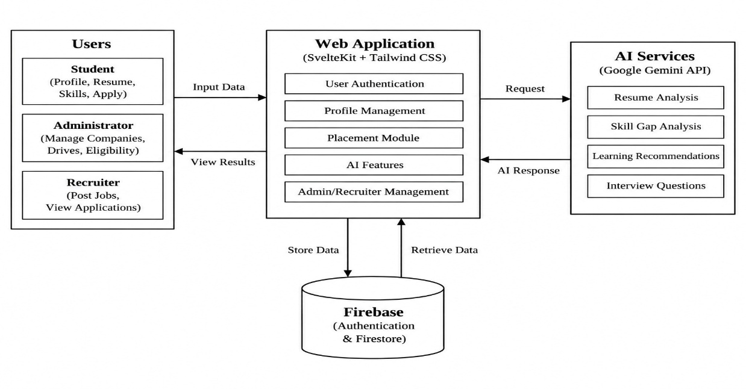
Fig 5.1 System Architecture

5.2 USE CASE DIAGRAM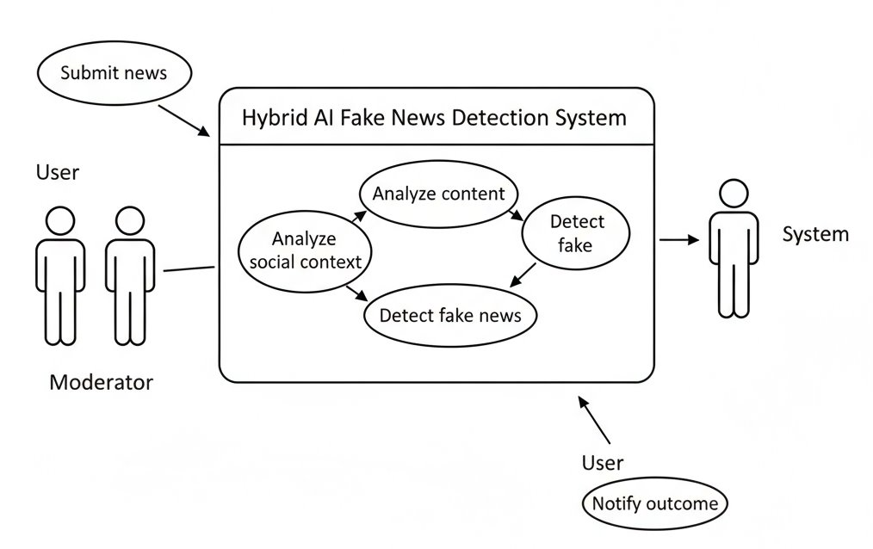
Fig 5.2 Use Case Diagram

The system starts when a student logs in. The student can upload a resume, manage skills, and get career recommendations. The system analyzes the resume and identifies skill gaps. It also provides mock interviews and feedback. Finally, the system calculates the career readiness score and displays the results to the student.
The placement officer can view student details, placement information, and application details. The recruiter can post job opportunities and view student applications.

5.3 CLASS DIAGRAM
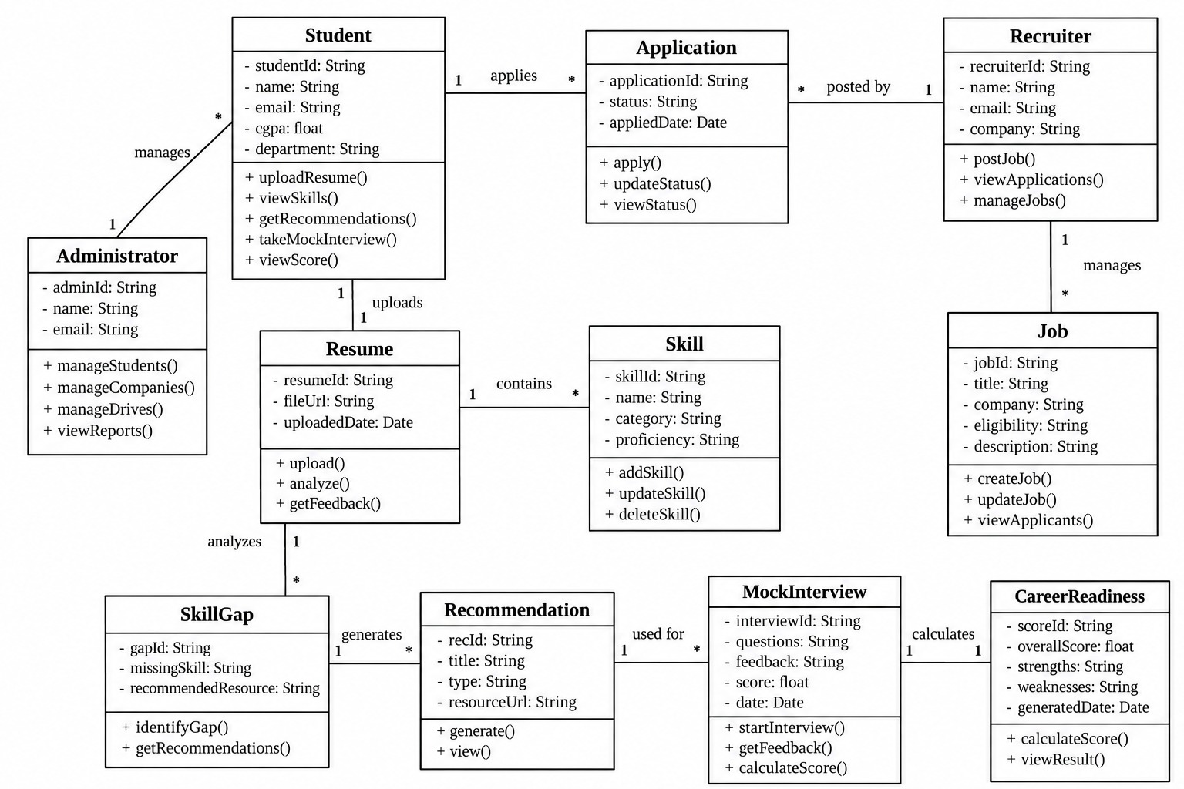
Fig 5.3 Class Diagram

CHAPTER 6
PROPOSED ALGORITHM IMPLEMENTATION
6.1 PROJECT DESCRIPTION
The proposed CareerReady AI – Campus Placement and Candidate Readiness Platform is designed to help students prepare for campus placements and improve their career readiness. The system uses Artificial Intelligence to analyze student information, resumes, skills, and placement requirements.
Students can create their profile, add their skills, projects, certifications, and upload their resume. The system analyzes the resume and identifies missing skills. It also provides suitable recommendations to help students improve their skills and resume.
The system provides AI-based mock interview preparation. Students can practice technical, HR, behavioral, and coding questions and receive feedback. Based on the student's profile, skills, resume, and interview performance, the system calculates a career readiness score.
The platform also supports placement activities. Students can view job opportunities, check eligibility, and apply for suitable jobs. Administrators can manage students, companies, placement drives, and eligibility details. Recruiters can post jobs and view applications.
The system is developed using SvelteKit, Svelte, Tailwind CSS, Firebase Authentication, Cloud Firestore, and Gemini AI. Overall, CareerReady AI provides a single platform for resume improvement, skill development, interview preparation, and campus placement management.
6.2 MODULES
The proposed CareerReady AI system is organized into the following key modules for easy understanding and implementation:
• User Authentication
• Student Profile Management
• Resume Upload and Analysis
• Skill Management
• Skill Gap Analysis
• AI Interview Preparation
• Career Recommendations
• Placement and Job Management
• Eligibility and Application Management
• Career Readiness Score
• Administrator Management
• Recruiter Management
• Notifications and Reports
6.3 MODULES DESCRIPTION
6.3.1 USER AUTHENTICATION
The User Authentication module provides login and registration for the system. There are three types of users: Student, Administrator, and Recruiter. Each user logs in using their account and gets access to features based on their role. Firebase Authentication is used to manage user accounts securely.

6.3.2 STUDENT PROFILE MANAGEMENT
The Student Profile Management module allows students to enter and update their personal and academic details. Students can add information such as name, email, department, CGPA, skills, projects, and certifications. This information is used by the system to provide suitable placement support and recommendations.
6.3.3 RESUME UPLOAD AND ANALYSIS
The Resume module allows students to upload their resumes. The AI system analyzes the resume and checks important details such as skills, education, projects, and experience. It provides suggestions to improve the resume and helps students understand whether their resume is suitable for placement opportunities.
6.3.4 SKILL GAP ANALYSIS
The Skill Gap Analysis module checks the student's current skills against the skills required for a selected job role. The system identifies missing or weak skills and displays them to the student. This helps students understand which skills they need to improve.
6.3.5 AI INTERVIEW PREPARATION
The AI Interview Preparation module helps students practice for interviews. The system can generate technical, HR, behavioral, and coding questions based on the student's profile and selected job role. Students can answer the questions and receive AI-based feedback to improve their preparation.
6.3.6 PLACEMENT AND JOB MANAGEMENT
The Placement and Job Management module manages company and job information. Administrators and recruiters can add job details, eligibility requirements, and placement opportunities. Students can view available jobs, check their eligibility, and apply for suitable opportunities.
6.3.7 CAREER RECOMMENDATION
The Career Recommendation module provides personalized suggestions to students. Based on their skills, resume, academic details, and career interests, the system suggests suitable skills, learning areas, and job roles.
6.3.8 CAREER READINESS SCORE
The Career Readiness module calculates an overall readiness score based on the student's profile, skills, resume, interview performance, and other placement-related information. The score helps students understand their current preparation level.
6.3.9 ADMINISTRATOR AND RECRUITER MANAGEMENT
The Administrator and Recruiter module provides features for managing placement activities. Administrators can manage students, companies, placement drives, eligibility, and applications. Recruiters can post jobs and view applications from students.
6.3.10 DATABASE MANAGEMENT
The Database Management module stores and retrieves system information. Firebase Cloud Firestore is used to store student profiles, resumes, skills, jobs, applications, interviews, and other placement information.
6.4 ALGORITHM DESCRIPTION
6.4.1 AI-BASED ALGORITHMS USED IN CAREERREADY AI
The proposed CareerReady AI system uses Artificial Intelligence and Natural Language Processing to provide personalized placement support. The main AI-based methods used in the system are described below.

- Resume Analysis
The Resume Analysis module processes the uploaded resume and identifies important information such as education, skills, projects, and experience. AI is used to understand the resume content and provide suggestions for improvement.
- Skill Gap Analysis
The Skill Gap Analysis algorithm compares the student's existing skills with the skills required for a selected job role. It identifies missing skills and shows the areas that the student needs to improve.
- AI-Based Recommendations
The recommendation algorithm uses student information such as skills, interests, resume details, and job requirements. Based on this information, the system provides suitable learning and career recommendations.
- AI Interview Question Generation
The AI interview algorithm generates questions based on the student's skills and selected job role. It can generate technical, HR, behavioral, and coding questions for practice.
- Interview Feedback
The system analyzes the student's interview answers and provides feedback. It can identify areas that need improvement and provide suggestions for better interview preparation.
- Career Readiness Score
The Career Readiness algorithm combines information such as skills, resume analysis, interview performance, and academic details to calculate an overall readiness score. This score helps students understand their preparation level.

6.4.2 AI PROCESS FLOW
The basic AI process of the system is:
- Collect student information.
- Upload and analyze the resume.
- Identify the student's skills.
- Compare skills with job requirements.
- Identify skill gaps.
- Generate learning and career recommendations.
- Generate mock interview questions.
- Analyze interview performance.
- Calculate the career readiness score.
- Display the results to the student.
Overall, the AI-based approach helps CareerReady AI provide personalized placement preparation. It combines resume analysis, skill-gap identification, recommendations, interview preparation, and career scoring in a single platform.

CHAPTER 7
SYSTEM TESTING
7.1 TESTING
The purpose of testing is to ensure that the CareerReady AI system works correctly and meets its requirements. Testing helps to find errors and problems in the system before it is used by students, administrators, and recruiters.
In this project, testing was performed on important features such as login, student profile, resume upload, resume analysis, skill-gap analysis, AI interview, recommendations, job management, eligibility checking, and applications.
Testing also checked whether the different modules work together correctly. It ensured that student and placement data is stored and retrieved properly and that the AI features provide the expected results.
7.2 UNIT TESTING
Unit testing is used to test each module separately. Each feature of the CareerReady AI system was tested to make sure it works correctly.
The following functions were tested:
• User login and registration work correctly.
• Student profile details can be added and updated.
• Resume can be uploaded successfully.
• Resume analysis provides the expected result.
• Skills can be added and updated.
• Skill gaps can be identified correctly.
• AI interview questions can be generated.
• Job details can be added and displayed.
• Students can check eligibility and apply for jobs.
Unit testing helped identify and fix errors during development.

7.3 INTEGRATION TESTING
Integration testing checks whether different modules work correctly when they are connected together. After testing each module separately, the modules were combined and tested.
The testing verified:
• Login connects correctly with user profiles.
• Student details are correctly connected with resume analysis.
• Resume and skill information are used for skill-gap analysis.
• AI services receive the required student information.
• Job details are connected with eligibility checking and applications.
• Firebase Authentication and Firestore work correctly with the application.
Integration testing ensured that data moves correctly between the different modules.
7.4 VALIDATION TESTING
Validation testing checks whether the system meets the requirements of the users. The CareerReady AI system was tested using different student profiles, resumes, skills, job requirements, and interview inputs.
The testing verified whether:
• Students can use the system easily.
• Resume analysis provides useful results.
• Skill gaps are displayed correctly.
• AI interview questions are generated based on the selected job role.
• Recommendations are related to the student's profile.
• Eligibility results are displayed correctly.
• Students can apply for suitable jobs.
• Administrators can manage placement information.
• Recruiters can post jobs and view applications.
The validation testing confirmed that the CareerReady AI system provides the required features for student placement preparation and placement management.
7.5 TEST CASES
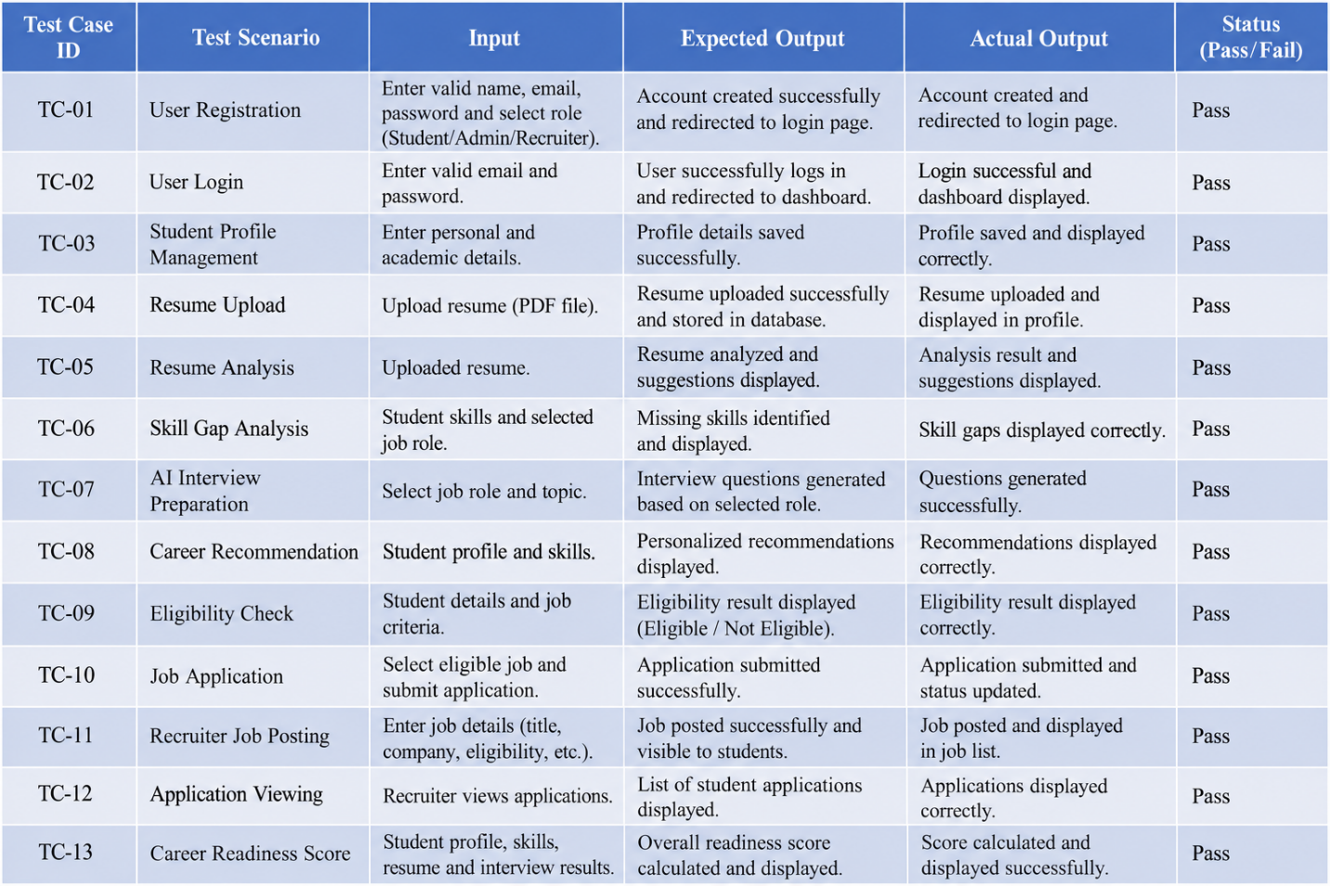
Fig 7.1 Test Report and Test Result

CHAPTER 8
RESULT AND DISCUSSION
The results of the CareerReady AI – Campus Placement and Candidate Readiness Platform show that the system successfully provides placement support to students, administrators, and recruiters. The main features of the system were tested to check whether they work correctly and provide the expected results.
- USER AUTHENTICATION
The login and registration module allows students, administrators, and recruiters to access the system using their accounts. The system provides different features based on the user's role.
- STUDENT PROFILE
Students can enter and update their personal, academic, and career details. The profile information is stored successfully and can be used by other modules.
- RESUME ANALYSIS
Students can upload their resumes and receive AI-based analysis. The system identifies important resume information and provides suggestions for improvement.
- SKILL GAP ANALYSIS
The system compares the student's skills with the skills required for a selected job. It identifies missing skills and helps students understand which areas need improvement.
- AI INTERVIEW PREPARATION
The system generates interview questions based on the selected job role and student profile. Students can practice technical, HR, behavioral, and coding questions and receive feedback.
- CAREER RECOMMENDATIONS
The system provides personalized recommendations based on the student's skills, resume, academic details, and career interests. These recommendations help students improve their career preparation.
- CAREER READINESS SCORE
The system calculates a career readiness score using student information, skills, resume analysis, and interview performance. The score helps students understand their current preparation level.
- PLACEMENT MANAGEMENT
Students can view available jobs, check their eligibility, and apply for suitable opportunities. Administrators and recruiters can manage job and placement information.
- APPLICATION MANAGEMENT
The system allows students to submit applications and allows recruiters or administrators to view application details. The application status can also be managed through the system.
- OVERALL RESULT
The testing results show that the major modules of CareerReady AI work as expected. The system successfully combines student profile management, resume analysis, skill-gap analysis, AI interview preparation, recommendations, career scoring, and placement management in one platform.
Overall, the proposed system provides a simple and centralized platform for improving student placement readiness. It reduces manual work and provides useful AI-based support to students, while administrators and recruiters can manage placement activities more efficiently.

CHAPTER 9
CONCLUSION AND FUTURE ENHANCEMENTS
9.1 CONCLUSION
In conclusion, the CareerReady AI – Campus Placement and Candidate Readiness Platform provides a centralized system for helping students prepare for campus placements. The system combines student profile management, resume analysis, skill-gap analysis, AI interview preparation, career recommendations, and placement management in one platform.
The system uses Artificial Intelligence to analyze student information and provide personalized guidance. Students can upload their resumes, identify missing skills, practice interviews, receive recommendations, and check their career readiness score. Administrators and recruiters can also manage placement activities, jobs, and applications.
Overall, CareerReady AI reduces manual work and provides students with useful tools to improve their placement preparation. The system provides a simple and effective solution for student career development and campus placement management.
9.2 FUTURE ENHANCEMENT
• Mobile Application: The system can be extended into a mobile application so that students can access placement preparation features from their smartphones.
• Advanced AI Resume Analysis: More advanced AI models can be added to provide detailed resume analysis and better ATS-based suggestions.
• Improved Interview Evaluation: Future versions can evaluate student answers, communication, and interview performance in more detail.
• Personalized Learning Path: The system can provide a step-by-step learning path based on the student's skill gaps and career goals.
• Job Recommendation: The system can recommend suitable jobs based on student skills, interests, qualifications, and company requirements.
APPENDIX
A.1 SOURCE CODE
import pandas as pd
import numpy as np
import string
import re
import sys
from sklearn.model_selection import train_test_split
from sklearn.metrics import classification_report
from sklearn.linear_model import LogisticRegression
from sklearn.tree import DecisionTreeClassifier
from sklearn.ensemble import GradientBoostingClassifier
from sklearn.ensemble import RandomForestClassifier
from sklearn.svm import LinearSVC
from sklearn.feature_extraction.text import TfidfVectorizer
import xgboost as xgb
try:
data_fake = pd.read_csv('E:/Miniupdated/Fake.csv', engine='python', on_bad_lines='skip')
data_true = pd.read_csv('E:/Miniupdated/True.csv', engine='python', on_bad_lines='skip')
print("Data loaded successfully.")
print(f"Fake data shape: {data_fake.shape}")
print(f"True data shape: {data_true.shape}")
except Exception as e:
print(f"Error loading files. Ensure they are at the correct path: {e}")
sys.exit(1) # Exit if data loading fails
data_fake["class"] = 0
data_true['class'] = 1
data_fake_manual_testing = data_fake.tail(10)
data_fake = data_fake.iloc[:-10]
data_true_manual_testing = data_true.tail(10)
data_true = data_true.iloc[:-10]
data_merge = pd.concat([data_fake, data_true], axis = 0)
data = data_merge.drop(['title','subject','date'], axis = 1)
if data.isnull().sum().any():
data.dropna(inplace=True)
data = data.sample(frac = 1, random_state=42).reset_index(drop=True)
print("\nMerged and Shuffled Data Head (ready for preprocessing):")
print(data.head())
def wordopt(text):
text = str(text) # Ensure input is treated as string
text = text.lower()
text = re.sub('\\[.*?\\]','',text)
text = re.sub("\\W"," ",text)
text = re.sub('https?://\\S+|www\\.\\S+','',text)
text = re.sub('<.*?>+', '', text)
text = re.sub('[%s]' % re.escape(string.punctuation),'',text)
text = re.sub('\\w*\\d\\w*','',text)
text = re.sub('\\s+', ' ', text).strip()
return text
def output_lable(n):
if n == 0:
return "Fake News"
elif n == 1:
return "Not A Fake News (TRUE)"
else:
return "Unknown Label"
def print_model_results(model, name, xv_test, y_test, pred):
print(f"\n--- {name} Results ---")
print(f"Accuracy: {model.score(xv_test, y_test):.4f}")
print("Classification Report:\n", classification_report(y_test, pred))
data['text'] = data['text'].apply(wordopt)
print("\nText data after cleaning (first 3 articles):")
print(data['text'].head(3))
x = data['text']
y = data['class']
x_train, x_test, y_train, y_test = train_test_split(x, y, test_size = 0.25, random_state=42)
vectorization = TfidfVectorizer()
xv_train = vectorization.fit_transform(x_train)
xv_test = vectorization.transform(x_test)
print(f"\nTraining set shape (X_train): {xv_train.shape}")
print(f"Testing set shape (X_test): {xv_test.shape}")
LR = LogisticRegression(solver='liblinear', random_state=42)
print("\nTraining 1. Logistic Regression...")
LR.fit(xv_train, y_train)
pred_lr = LR.predict(xv_test)
print_model_results(LR, "Logistic Regression", xv_test, y_test, pred_lr)
DT = DecisionTreeClassifier(random_state=42)
print("\nTraining 2. Decision Tree Classifier...")
DT.fit(xv_train, y_train)
pred_dt = DT.predict(xv_test)
print_model_results(DT, "Decision Tree Classifier", xv_test, y_test, pred_dt)
RF = RandomForestClassifier(random_state = 42)
print("\nTraining 3. Random Forest Classifier...")
RF.fit(xv_train, y_train)
pred_rf = RF.predict(xv_test)
print_model_results(RF, "Random Forest Classifier", xv_test, y_test, pred_rf)
GB = GradientBoostingClassifier(n_estimators=50, learning_rate=0.5, random_state = 42)
print("\nTraining 4. Gradient Boosting Classifier...")
GB.fit(xv_train, y_train)
pred_gb = GB.predict(xv_test)
print_model_results(GB, "Gradient Boosting Classifier", xv_test, y_test, pred_gb)
SVM = LinearSVC(random_state=42, max_iter=2000)
print("\nTraining 5. Support Vector Machine (LinearSVC)...")
SVM.fit(xv_train, y_train)
pred_svm = SVM.predict(xv_test)
print_model_results(SVM, "Support Vector Machine (LinearSVC)", xv_test, y_test, pred_svm)
XGB = xgb.XGBClassifier( objective='binary:logistic', use_label_encoder=False, eval_metric='logloss', n_estimators=100, random_state=42)
print("\nTraining 6. Extreme Gradient Boosting (XGBoost)...")
XGB.fit(xv_train, y_train)
pred_xgb = XGB.predict(xv_test)
print_model_results(XGB, "XGBoost", xv_test, y_test, pred_xgb)
def manual_testing(news):
testing_news = {"text":[news]}
new_def_test = pd.DataFrame(testing_news)
new_def_test['text'] = new_def_test["text"].apply(wordopt)
new_x_test = new_def_test["text"]
new_xv_test = vectorization.transform(new_x_test)
pred_LR = LR.predict(new_xv_test)
pred_DT = DT.predict(new_xv_test)
pred_RF = RF.predict(new_xv_test)
pred_GB = GB.predict(new_xv_test)
pred_SVM = SVM.predict(new_xv_test)
pred_XGB = XGB.predict(new_xv_test)
print("\n--- FINAL PREDICTION RESULTS (6 MODELS) ---")
print("1. LR Prediction: {}".format(output_lable(pred_LR[0])))
print("2. DT Prediction: {}".format(output_lable(pred_DT[0])))
print("3. RF Prediction: {}".format(output_lable(pred_RF[0])))
print("4. GBC Prediction: {}".format(output_lable(pred_GB[0])))
print("5. SVM Prediction: {}".format(output_lable(pred_SVM[0])))
print("6. XGB Prediction: {}".format(output_lable(pred_XGB[0])))
print("--------------------------------------------------")
print("\n\n" + "="*80)
print("BEGIN MANUAL NEWS CLASSIFICATION")
print("="*80)
print("PASTE YOUR NEWS ARTICLE BELOW:")
print("After pasting, press ENTER, then press CTRL+D (or CTRL+Z on Windows) to submit.")
print("---------------------------------------------------------------------------------")
try:
news_input = sys.stdin.read()
except EOFError:
news_input = ""
except Exception as e:
print(f"An error occurred while reading input: {e}")
news_input = ""
if news_input.strip():
manual_testing(news_input)
else:
print("\nNo news article was entered. Exiting manual testing block.")
A.2 SCREENSHOTS
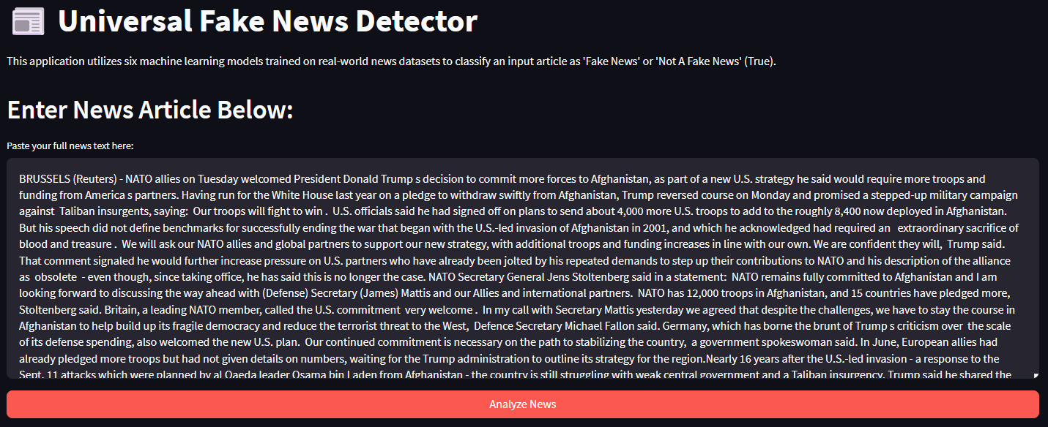
Fig A.2.1
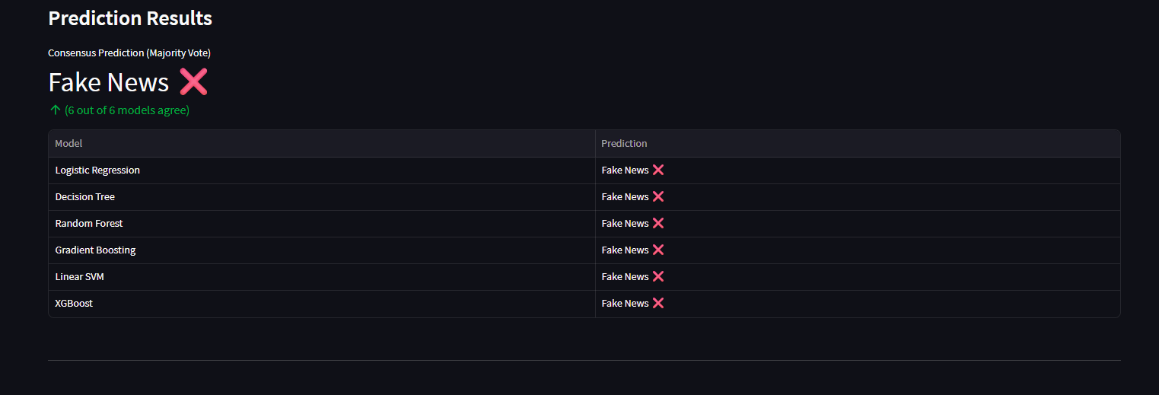
Fig A.2.2
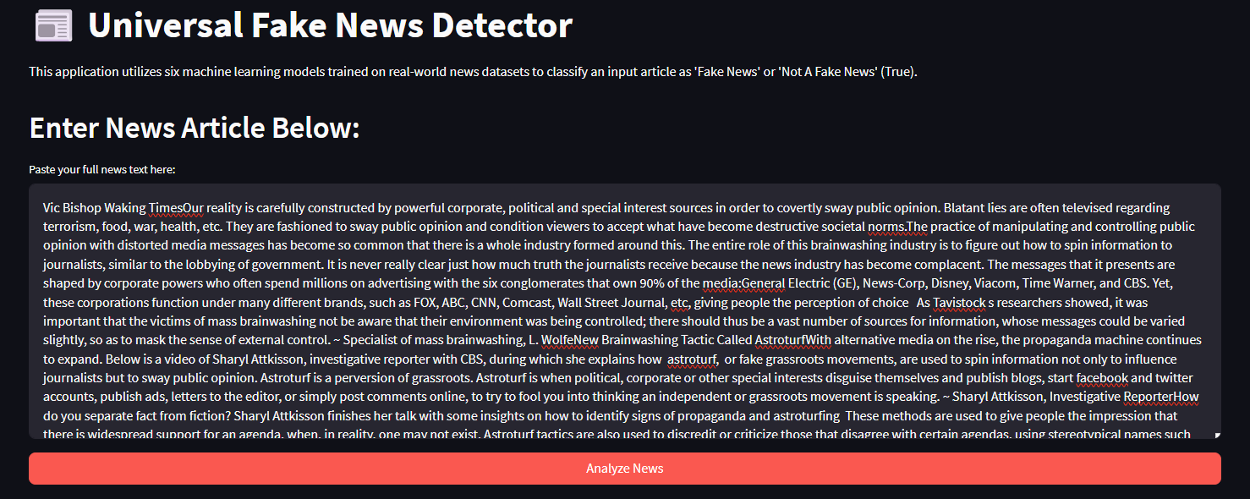
Fig A.2.3
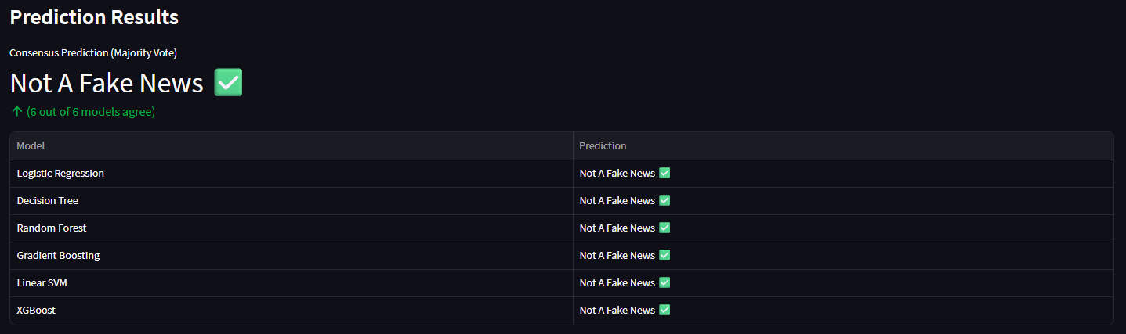
Fig A.2.4
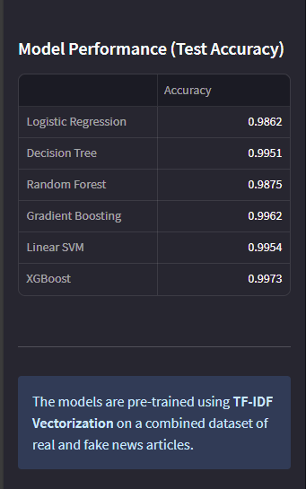
Fig A.2.5
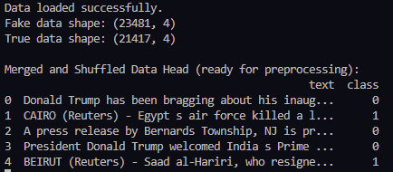
Fig A.2.6
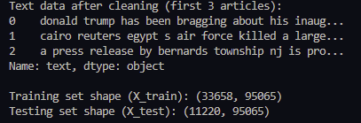
Fig A.2.7
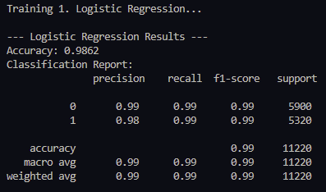
Fig A.2.8
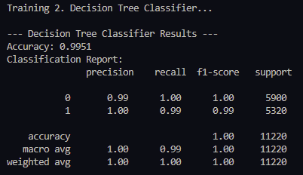
Fig A.2.9

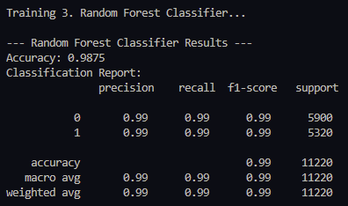
Fig A.2.10
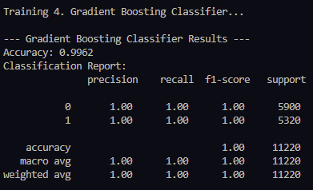
Fig A.2.11
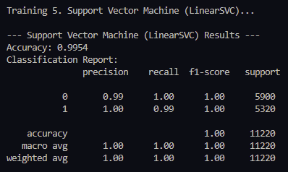
Fig A.2.12
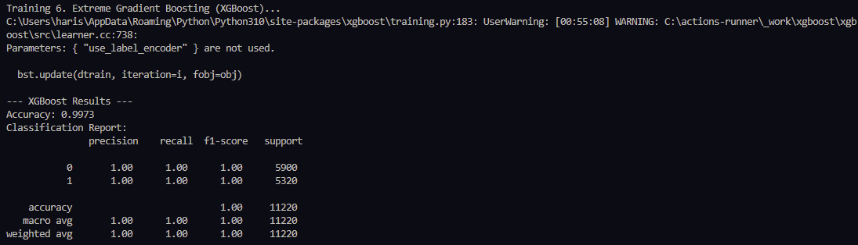
Fig A.2.13
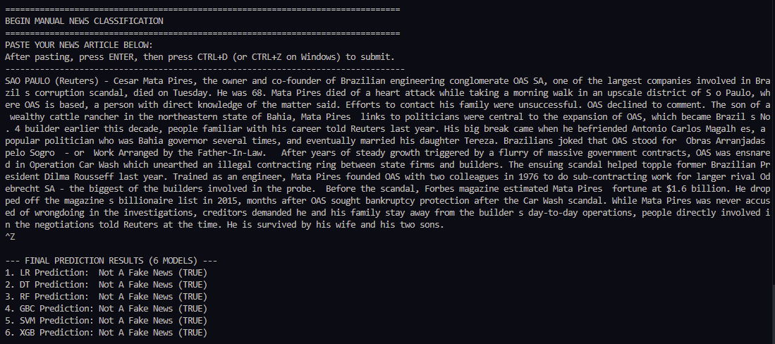
Fig A.2.14
REFERENCES
1] Gan, C., Zhang, Q., & Mori, T. (2024). Application of LLM Agents in Recruitment: A Novel Framework for Automated Resume Screening. Journal of Information Processing, 32, 881–893. https://doi.org/10.2197/ipsjjip.32.881.
[2] Mishra, A., Singh, S., & Jisha, R. C. (2024). AI-Powered Model for Intelligent Resume Recommendation and Feedback. 2024 15th International Conference on Computing Communication and Networking Technologies (ICCCNT). IEEE. https://doi.org/10.1109/ICCCNT61001.2024.10726016.
[3] Panchasara, H., Gupta, S., & Sharma, R. (2023). AI Based Job Recommendation System using BERT. 2023 7th International Conference on Computing, Communication, Control and Automation (ICCUBEA). IEEE. https://doi.org/10.1109/ICCUBEA58933.2023.10392119.
[4] ResuméAtlas: Revisiting Resume Classification with Large-Scale Datasets and Large Language Models. (2024). Procedia Computer Science, 244, 158–165. https://doi.org/10.1016/j.procs.2024.10.189.
[5] JobEdKG: An Uncertain Knowledge Graph-Based Approach for Recommending Online Courses and Predicting In-Demand Skills Based on Career Choices. (2023). Engineering Applications of Artificial Intelligence, 126, 107779. https://doi.org/10.1016/j.engappai.2023.107779.
[6] Wilson, K., & Caliskan, A. (2024). Gender, Race, and Intersectional Bias in Resume Screening via Language Model Retrieval. arXiv. https://arxiv.org/abs/2407.20371.
[7] Canagasuriam, D., & Lukacik, E.-R. (2025). ChatGPT, Can You Take My Job Interview? Examining Artificial Intelligence Cheating in the Asynchronous Video Interview. International Journal of Selection and Assessment, 33, e12491. https://doi.org/10.1111/ijsa.12491.
[8] Pharmacy Student Perceptions of Using AI-Based Interview Software for Career Preparation. (2024). American Journal of Pharmaceutical Education, 88(9), 101263. https://doi.org/10.1016/j.ajpe.2024.101263.

